Calendar year 2018 has been a challenging year for Indian Equity markets. Some of the correction and volatility was expected due to macro headwinds and high base of CY17. We had an extremely good CY17 when Nifty 50 Index went up 29%, NSE Mid Cap Index 47% and Nifty Small cap ended with over 57% gains. Thus, we have seen some rollback of returns in the current year. To highlight, we have ended a year with 3% gains in Nifty Index while Nifty Midcap Index and Small-cap Index have seen correction of 15% and 29% respectively.

We believe that one year is not a right tenure to judge performance of any asset class. Thus, we go further to see the longer-term performance of Indian markets and we would like to highlightthat 5-year basis, Nifty Index has delivered over CAGR of over 12% while Nifty Midcap and BSE Small-cap Indices have yielded over 17% and 18% CAGR. Therefore, we see CY18 as a year of normalisation wherein a part of the gains which we have seen in last 4-5 years have gone as the valuations in most of the mid-small caps and some selective large-caps have seen some bit of moderation.



**Source:** Bloomberg. As of 31-Dec-2018

India has seen as largely a domestic economy that has progressively become dependent on and increasingly linked to global markets. That has, however, also meant that global swings- unless extreme (2008, 2013) - have tended to be more confined to the market rather than having any material economic influence or impact. In most cases, an unfavourable global trend has had an offset impact for India for example the impact of rising US rates or falling global equity markets (negative for India) has been negated by falling oil prices which is positive for India. Therefore, we don’t see any major global event impacting India unless it’s very extreme.

As far as 2019 is concerned, outlook can be looked in two parts- the first would be macros and second, the corporate earnings. So far macros are concerned, falling crude prices will be a positive for Indian economy as it would help reduce the imports materially and would support the currency as well. India would head into General Elections in first half of 2019. While, calling elections is tough and we don’t pretend to do so, what we believe is that the result is unlikely to have any major implications on long-term growth prospects of Indian economy. The Indian economy has been formalising and growing with all the reforms that each government has been bringing over last few decades. As investors, the better thing for us is to look at bigger picture as the wealth creation would happen over longer-term. From the corporate earnings prospective, we expect a very risk-neutral scenario for next 2-3 years and thus a relatively smoother ride driven by-

1. favorable base effect for corporate lenders and slowing down of the NPA recognition cycle
2. steady consumption and asset utilisation driven by premiumisation, rural demand, manufacturing and government spend on infrastructure
3. improvement in exports led by pharma while IT exports are likely to sustain their recent trend

Despite of the correction while valuations have not become very attractive, they aren’t too expensive either. So far macro indicators are concerned, the Indian economy continues to expand around 7% and remainsamongst fastest growing economies in the world. The per-capita income of the country, irrespective of any government, has been expanding and the country is gradually emerging from ‘lower-middle income economy’ to ‘upper-middle income economy’. Considering the major reforms that the government is bringing in, digitisation, capital inflows and prevailing scope for infrastructure development keeps India in the brightest spot amongst the emerging economies in the world and makes a classic case for investments. Therefore, we feel that the yearly returns should be seen as an aberration and every investor should look at the long-term investment opportunity.

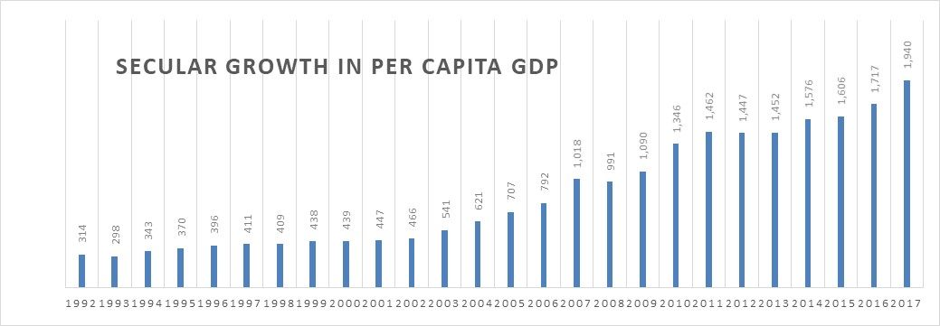

**Source:** World Bank, Value in USD terms

Portfolio outlook:

Given a situation, where overall market valuations are above long-term averages and the nation is heading towards election, volatility is likely to persist over next 5-6 months. Therefore, it would be prudent to have a multi-cap portfolio with ideal mix of large and midcap stocks while having some buffer cash which would be deployed at appropriate levels in fundamentally strong companies. Our stringent investment processes would continue to help us find companies with strong business fundamentals and as you might have seen, we have initiated few stocks in the portfolio. The investment process broadly represents following characteristics-

1. Companies with strong management with history of good governance practices
2. Strong financial track record
3. Has reasonable growth prospects
4. And lastly, is available at reasonable price

We believe, it is a good opportunity for investors to take advantage of volatility in the first half of 2019 to build equity portfolio for long-term.

Lastly, we would like to wish everyone A Very Happy & Prosperous New Year 2019.